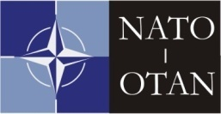 | NORTH ATLANTIC TREATY ORGANISATION  NATO MARITIME INTERDICTION OPERATIONAL TRAINING CENTRE  NMIOTC  SOUDA NAVAL BASE  73200 CHANIA  GREECE | 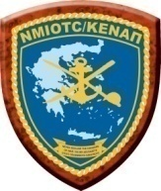

6th Annual NMIOTC Conference Joining Request Form
(please read carefully the instructions below prior to filling out the form)
PERIOD: 02-04 June 2015
SPEAKER/ATTENDEE'S INFORMATION
Last Name (*)
First Name (*)
Middle Initials
Sex (*)
Nationality (*)
Military Rank / Title for Civilians (*)
Organization / Branch / Service (*)
Title of duty position (*)
Date of Birth
ID No/Passport No (*)
Tel (*)
E-mail (*)
Accompanied by spouse / family
Non paper drafting contribution
TRAVELLING INFORMATION
Travel Mode to NMIOTC (*)
Arrival Date (*)
Departure Date (*)
Accommodation (*)
Rental Car
COMMENTS / REMARKS
INSTRUCTIONS
1. Information marked as (*) is mandatory.

2. This form must be completed in capital letters, saved as Annual NMIOTC Conference_Surename_Rank.Doc. and be submitted to :
a. studentadmin@nmiotc.grc.nato.int into NU-WAN, or
b. ariatzisn@nmiotc.grc.nato.int, or
c. FAX: +30 28210 85702 to NMIOTC Admin Officer, Lt JG Konstantinos Papanastasis GRC(N).

3. If information on a field is not applicable or not yet determined can be filled with N/A or TBD respectively.

